Cranham Common walk with Helen

A lovely walk that my family and I often do (even on a snowy day!), is up and over Cranham common.

The circular walk starts from the village primary school, where there is a small parking area. The walk starts with a short sharp assent to the top of the common; where the views are worth the climb!
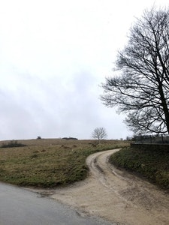

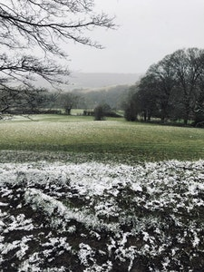

Once at the top, the walk continues along a flat path that runs parallel to the village cricket pitch and then through several large open fields.

Once through the second gate, you then start to quickly drop down hill (back towards the common), whilst enjoying more beautiful views and passing by a lovely large house and gardens (which were once rumoured to belong to the singer Lily Allen!).

The walk is just under 2 miles. Whilst there is no village shop, refreshments can be enjoyed in the village’s lovely traditional country pub, The Black Horse.

