Helen's Miserden Walk

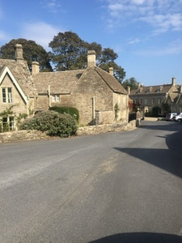
One of my family’s favourite walks is around Miserden Park Estate. The walk we like to do takes you through the beautiful pheasant wood and around a magnificent lake that is cocooned within the wood. There are several benches along the way that make lovely coffee and cake stops (for if you have brought your own), alternatively, the village pub, The Carpenters Arms, makes a rewarding end to the walk. There is also a village shop, great for ice-cream in the summer!

There is a public car park next to the school and additional parking can normally be found near the war memorial and village pub. The walk starts from the war memorial and then heads down the hill towards Miserden Estate nursery. At the bottom of this road is a large gate marked ‘private’ but with a small footpath gate to the side of it. This leads into the most fantastic expanse of a field, the footpath follows the road that winds through it.
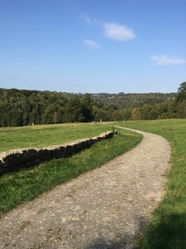

At the bottom of the field the footpath leads into, and then through the wooded area, over a stream with a pretty bridge and then continues alongside the stream through wonderful woods until you reach the beautiful Miserden Estate Lake.
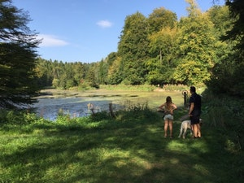

We love doing this walk all year round, the beauty of this hidden gem is in how the colours and feel of the landscape change so dramatically throughout the year. Wildlife including pheasants and deer can often be seen.
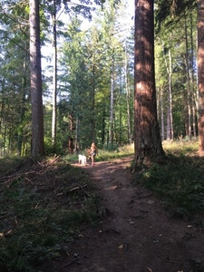

The walk is around 2.5 miles long and can be quite muddy in the winter!

