Kim's Crickley Hill Walk

This walk could raise £94 if you and a friend walk 2 miles and get sponsored by 12 friends and family (4 feet x 2 miles = £8 x 12 sponsors = £96)

Crickley Hill has so much to offer, it is little wonder that it is my favourite place to walk. From either of the two car parks, which you must pay for or you will get a fine, you can walk in several directions. There are marked paths or you can just stroll where you fancy. Walk on the flat open space that was once home to an Iron Age Hill Fort, there is plenty of space to run the dog or the children. The views are amazing and on a clear day you can see across to the Brecon Beacons of Wales, that’s 60 miles away!
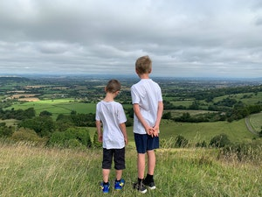
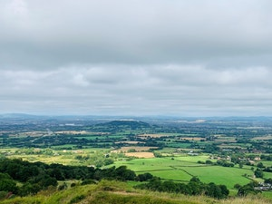

Check out the dew pond by the cricket pitch, constructed possibly as early as the 1850’s. There are woodlands to explore, kick through the leaves in autumn or just sit and listen to the various birdsong in spring. Look out for the kestrels and ravens that fly overhead or walk in the open land just outside the woods where the green woodpecker can often be seen and heard. Wild flowers grow here including orchids and the butterflies love it here too.

The joy of Crickley is the diversity. The open spaces, the views, the woodlands, the wildlife and fauna, choose the route you walk and the length of time you stay. You can’t get lost and many of the paths are suitable for wheelchairs and push chairs and when you need an ice cream or refreshments the little cafe has a good selection.

“Whatever the season this place invigorates me, it is my happy place.” Kim
