Kirsty's Cleeve Hill Walk

The walk we do most often with friends and family is on Cleeve Hill; we park at the quarry car park, and walk round the back of the hill, down towards the Washpool. The length can be varied according to who is walking and how much time you have. The terrain is varied, with gentle slopes and good paths.

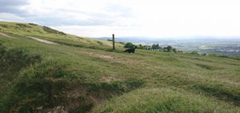

There are good views to the east of Winchcombe and Sudeley Castle, from the highest points west over Cheltenham and the river plain towards the Malverns and the Brecon Beacons and on a clear day all the way south to the Severn Bridges.
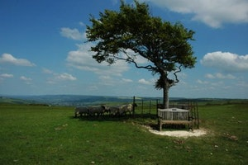

Interesting sights are the source of the River Isbourne trickling from the hill upstream of the Washpool, and near to the summit an Iron Age hillfort, with deep ditches in an area of the hill known as Cleeve Cloud.

Care should be taken when walking near the golf course as golfers are almost always on the fairways.

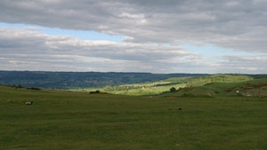

A three mile walk on Cleeve Hill walk could raise £360 if three friends or family and a dog walk with you and you have 10 sponsors (8 human feet + 4 canine feet = 12 x 3 miles = £36 x 10 sponsors = £360)

