Ray's River Coln Walk

This walk could raise you £600 if you plus three friends and family get 15 sponsors (8 feet x 5 miles = £40 x 15 sponsors = £600)
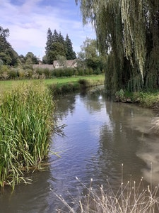

The walk from Coln St Aldwyns to Bibury largely follows the valley of the River Coln. It is about 2.5 miles each way, and contains a variety of scenery - meadows, woodland, and arable land mainly sown with barley. It is suitable for most walkers, the first half being flat along the river valley, and the later section climbing up slightly into Bibury. It has all the features which a good walk needs – a pub at either end, and a fine café with garden in Coln. The River Coln is well-known for its trout, which can often be seen from the bridge at Coln or when walking along the river bank in Bibury, and there are frequent sightings of swans, egrets, heron and deer along the route. Whilst in Bibury you can detour to see the famous Arlington Row Cottages or the Trout Farm. You can return along the same route, or there is an alternative way back along the ridge, which turns it into a fine 5 mile circular walk. Either way, it’s a delightful way to spend a pleasant day enjoying the best of the Cotswolds!

