Cobalt is pleased to bring you a convenient, user friendly and secure way for you to access and share your medical images with doctors, specialists and others. You will be able to access copies of your scan images online through your personal radiology portal. The link to access the web page is: <https://myvue.cobalthealth.co.uk>

**IMPORTANT** Your images are intended for medical interpretation and should be viewed with a qualified medical professional

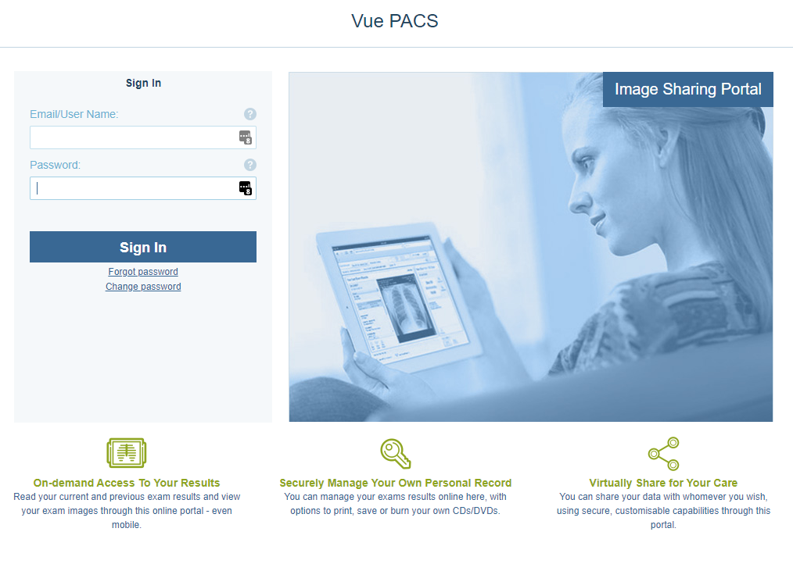

**Logging in to MyVue**

* We will send you two emails within 3 days of your visit to Cobalt, the first with a link to the MyVue site and a second with a system generated password. **Please double check our emails have not gone into your Junk or Spam folder.**
* You can reset your password to something more memorable the first time you log in to the system – **please note the password needs to be at least 8 characters long.**
* If you do not receive an email from us within 3 days of your visit, please call us on

**0800 1387201** and a member of our team will help you.

* After 90 days access to images is automatically removed by the system but can be reinstated at any time by contacting [**myvue@cobalthealth.co.uk**](mailto:myvue@cobalthealth.co.uk)

**Sharing your images**

In the **Share Exam** window, fill in the email address of the person that you would like to share the images with. **Mobile number is not required** and can be left blank. Complete the sharing options and tick the box to indicate that you understand the security implications of sharing medical information. An email will be sent with a link to your scan images.



To stop sharing your images, select **Exams Shared with Others** and click the bin icon next to the contact you want to remove access to your scan.

**Viewing your images**

You will be able to scroll through images by using the centre wheel on your mouse or press the up and down arrows on your keyboard.

Change views or ‘series’ of images by using the double arrows or the ‘series chooser’ button to the left. If your images are **blurry**, you are probably looking at series called surveys/scouts/localizers – these aren’t for diagnostic purposes, use the arrows to skip to the clearer series of images. Likewise, if you see this **exclamation sign**, do not worry, this indicates that the image is a survey - it is not a finding.

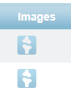**Multiple Scans?**

If you had more than one scan during your visit to Cobalt, look out for the link to ‘Previous Exams’ in the bottom left-hand corner to view a list of all of your scans. Then select the icon in the ‘Images’ column in line with the scan you want to open.

**FAQs**

|  |  |
| --- | --- |
| If I need help, what can I do? | Call **0800 1387201** or email: **myvue@cobalthealth.co.uk** |
| Can I view my report on MyVue? | No, your report will be sent to the medical professional who referred you for your scan so that they can discuss results and any onward treatment with you |
| How will I know when my images are ready? | You will receive an email from myvue@cobalthealth.co.uk |
| Which internet browsers can I use? | Edge, Internet Explorer, Google Chrome, Safari and Firefox |
| Can I use an Apple Mac Computer? | Yes, images will save to a Mac PC but once saved cannot be viewed on the launch viewer |
| Can I use a tablet or mobile phone? | Yes, although some features may operate differently and images may not save, it is not currently possible to share your images from a mobile phone |

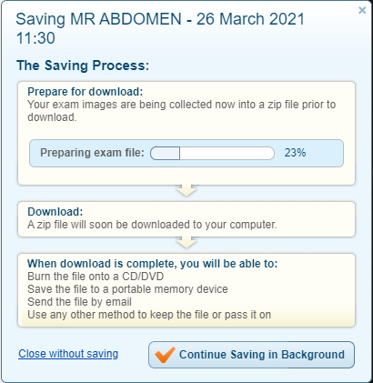**Saving your images**

Save your scan images locally to your **Downloads** folder as a ZIP file that contains DICOMDIR (medical image format) and JPEG files. You can then burn the files to a CD, USB or attach and send them by email. The images will be accessible to most hospitals and imaging centres.

The ‘Save Exam’ button only saves the scan you have opened, not all of your scans, so if you have multiple scans you will need to go into each one and save separately.